OLE-DB
With
Oracle to Teradata
Configuration
&
Operation
(Crib Sheet)

06-19-2000



By,
Scott Allen
Teradata Systems Group
NCR Corp.

Setting Up Oracle Client 8.1.5.0.0

This Crib Sheet was developed to document how to establish an Oracle to Teradata OLE-DB process from an NT Workstation. The process is straight forward but some details needed to be documented to assist others and hope this can save other PS associates time. Please feel free to update and share with others.

- After the program files for Oracle Client have been copied to the computer during install a screen will pop-up that will ask the user to setup Net8. Hit cancel to exit this utility.
- Go to Start → Programs → Oracle-OraHome81 → Network Administration → Net8 Easy Config:
- A window that resembles the following will appear:

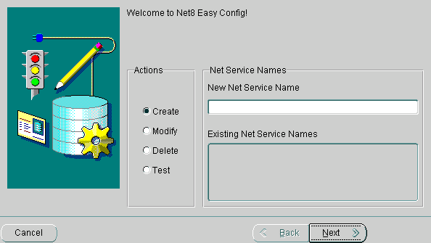
- In the New Net Service Name field enter the name of the server that you would like to connect to, in this example we will use scott.world (Please note that it is important that the .world extension follow the net service name).

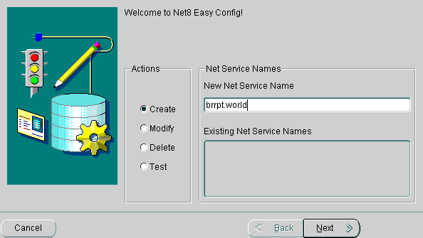
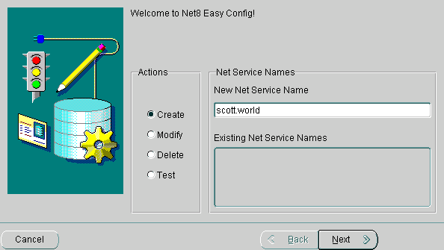
- Click the next button after the name has been entered. The following screen will appear:
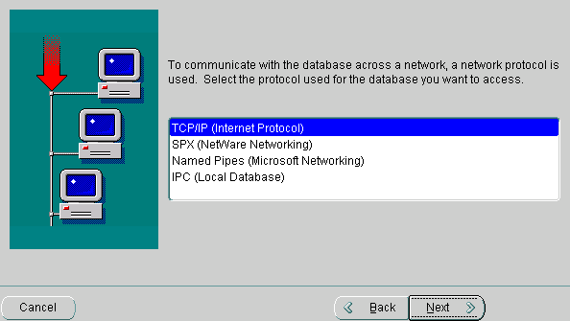
- Make sure that the correct network communication protocol is selected…in this example we will use ‘TCP/IP (Internet Protocol)’ is selected and click next.

- Under ‘Host Name:’ enter the IP address of the computer to which you would like to connect. (i.e. 234.56.789.10) In most cases the ‘Port Number:’ field will not need to be changed, as 1521 is the Oracle default. Click next.
- Select ‘Oracle8i release 8.0 or Previous:’ and enter the ‘Database SID:’ (The Database SID will be the ‘Net Service Name’ from window one without the .world extension. Click next.

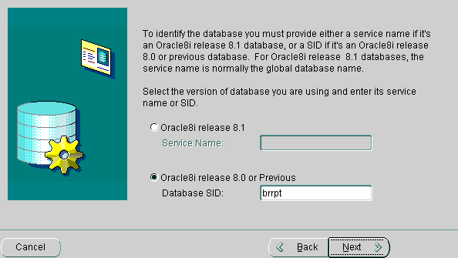
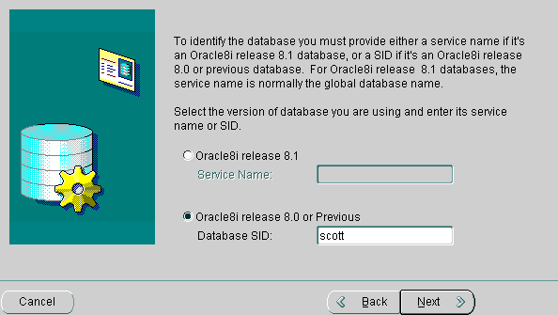
- The following screen will appear. Press the ‘Test:’ button.

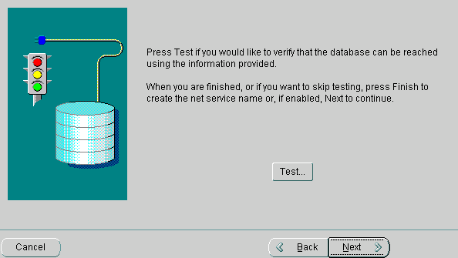
- The following will appear:

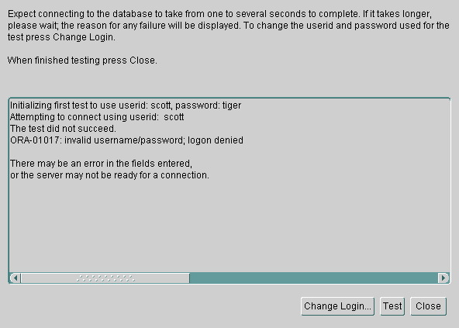
- The user id and password must be changed. Click on change login, and the following will appear:

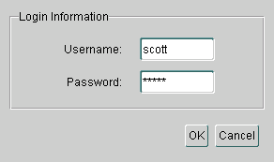
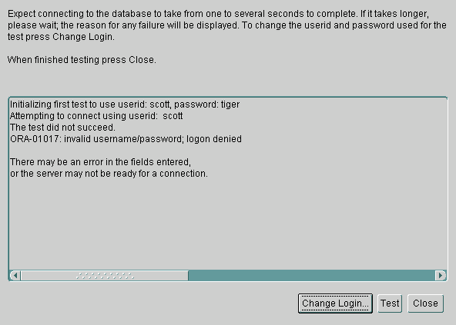
- Type the correct values into the ‘Username’ and ‘Password’ fields and hit ok. The test screen will then appear again.

- 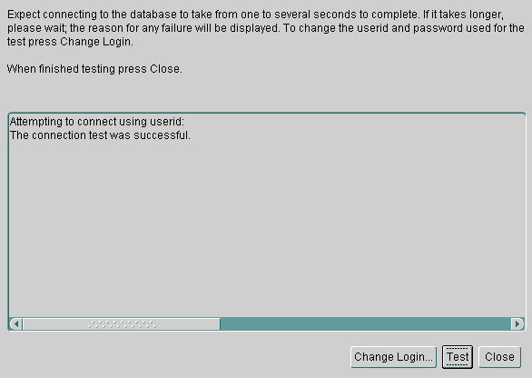Click test. If the communication is valid the following screen will appear:

- Click close and then next at the test screen. Click finished to save the changes that you made.
- Now you must edit the file tnsnames.ora, which will be found in the ‘c:\oracle\ora81\network\admin’ directory.

- Open the file with wordpad…it should resemble the following:

# C:\ORACLE\ORA81\NETWORK\ADMIN\TNSNAMES.ORA Configuration File:C:\Oracle\Ora81\NETWORK\ADMIN\tnsnames.ora
# Generated by Oracle Net8 Assistant

SCOTT.WORLD.HELLO.COM =
(DESCRIPTION =
(ADDRESS_LIST =
(ADDRESS = (PROTOCOL = TCP)(HOST = 234.56.789.10)(PORT = 1521))
)
(CONNECT_DATA =
(SID = scott)
)
)

- In some cases the network may add an extension to the above file after the <*.world>, such as ‘.HELLO.COM’ above.
- Delete the extension if there is one, so that the file resembles the following:

# C:\ORACLE\ORA81\NETWORK\ADMIN\TNSNAMES.ORA Configuration File:C:\Oracle\Ora81\NETWORK\ADMIN\tnsnames.ora
# Generated by Oracle Net8 Assistant

SCOTT.WORLD =
(DESCRIPTION =
(ADDRESS_LIST =
(ADDRESS = (PROTOCOL = TCP)(HOST = 234.56.789.10)(PORT = 1521))
)
(CONNECT_DATA =
(SID = scott)
)
)
- Save the changes to this file (if any), and close wordpad.
- OLE DB is now configured to communicate with Oracle.
- If you need to add additional servers, please repeat the steps above.
- Open OLE DB, select ‘Microsoft OLE DB Provider for Oracle (“MSDAORA”)’, and click on connection and you will see the following:

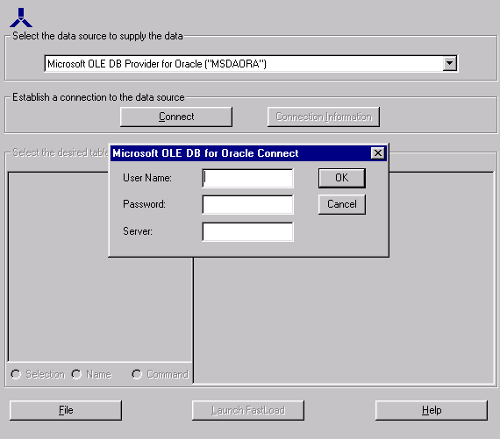
- Enter the ‘User Name:’, ‘Password’, and ‘Server’ for the database that you wish to log into and hit ‘OK’. (Note that the server name, in most cases, will be the ‘Net Service Name’ from Step 4)
- If everything is configured properly, the tables should appear on the left, and the columns within the selected table on the right.

